DZIUGAS SIAURUSAITIS CV
Agent contact:  Joint Stock Company „Aktoriu agentura“  Pilies st. 7-2, 01123, Vilnius, Lithuania  Ph./fax: +370 5 2611771  Mobile: +370 677 77493  Email: donatas@actorsagency.biz  Location: East Europe (Lithuania, Vilnius)  Height: 183 cm Weight: 85 Hair: Brown Eyes: Green-Brown Voice: Baritone  Languages: Lithuanian, English, Russian | 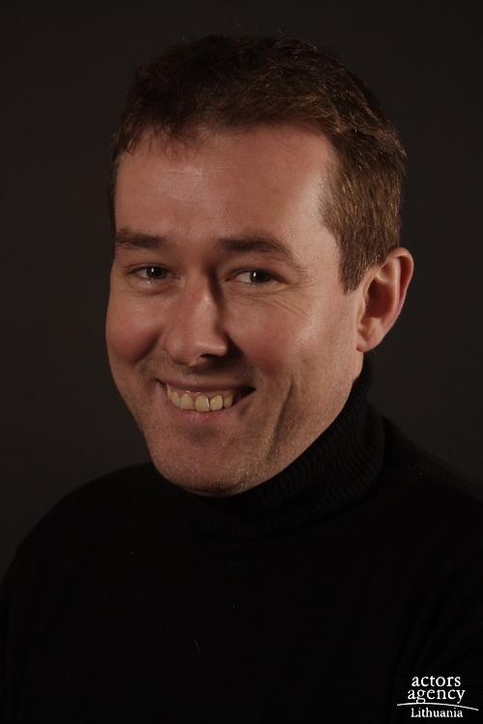

Date of Birth:
October 19, 1971

Film Roles

Guinevere Warrior Directed by Jud Taylor (USA)
1994
The New Adventures Peasant Created by Tom Kuhn &
of Robin Hood Fred Weintraub (USA) 1996
Warrior Angels Treasurer Directed by Byron W. Thompson
(USA) 2002
All alone Partisan Directed by Jonas Vaitkus
(Lithuania) 2002
Endangered Species Health Club Attendant Directed by Kevin Tenney (USA)
2002

Major Theatre Roles From 1991

The Tempest Prince Ferdinando Lithuanian National Drama Theater
The Rainmaker Jim Curry (lead) Lithuanian National Drama Theater
The Stranger The Arabian Lithuanian National Drama Theater
Chipolino Chipolino (lead) Lithuanian National Drama Theater
Women Songs Waiter Lithuanian National Drama Theater
Roberto Zucco Dancer Lithuanian National Drama Theater
Miguel Manjara Don Alfonso Lithuanian National Drama Theater
Stepancikov Village Vidopliasov Lithuanian National Drama Theater
Richard The 3rd The Killer Lithuanian National Drama Theater
Life is a Dream Servant Lithuanian National Drama Theater
Cinderella The Prince (lead) Lithuanian National Drama Theater
Madam Bovary Lereux Lithuanian National Drama Theater
The Demons Piotr Verchovensky (lead) Lithuanian National Drama Theater

Commercial Film

Bank “SNORAS” Shopper (lead) “idée fix” Lithuania
TELE – 2 Lover (lead) “idée fix” Lithuania
Kinder Spectator (lead) “RGB” Lithuania

Training

Lithuanian Music Academy:
Theatre and Film Department (1989 – 1993)
Bachelor Degree Completed (1993)

Another Jobs

Film Dubbing Television TV-3 (since 1993)
Situation Comedy Actor Television TV-3 (since2000)
“No Taboo” show editor Television TV-3 (since 2002)
“Amber Lady” show creator & emcee Television TV-3 (2003-2004)
“The Greatest show” show editor Television TV-3 (2006-2009)
“Hole in the wall” emcee Television TV-3 (2008-2009)

Special Skils

Swimming, Horseback, Basketball, Lawn Tennis, Football, Diving.

